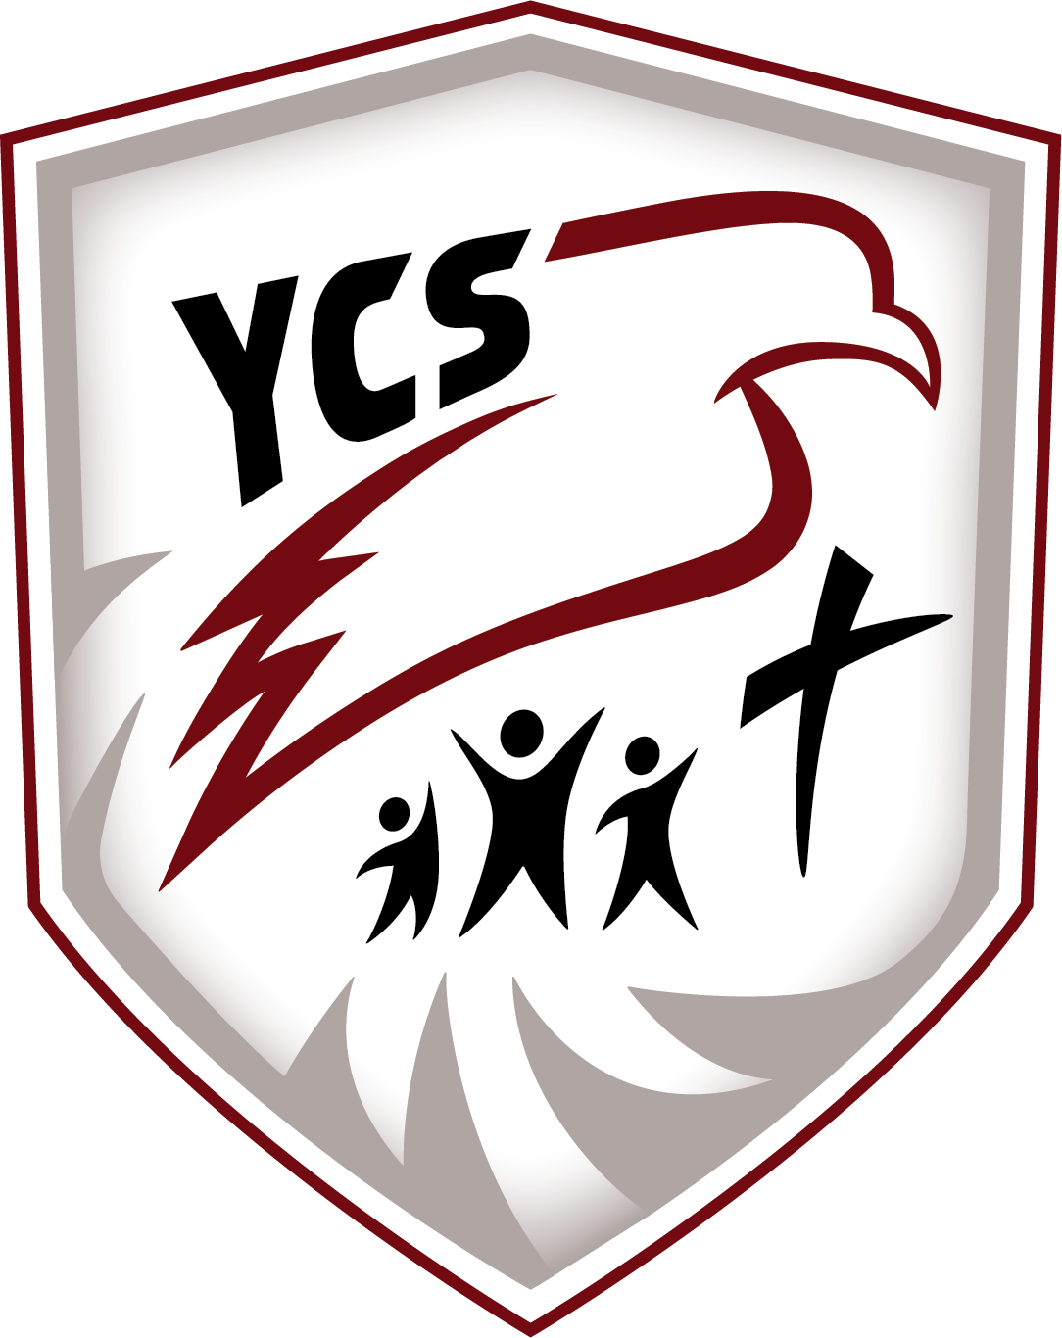

430 72nd Street, Edson, Alberta, T7E 1N3
Email: office@ykcschool.com Website: ycschool.ca
Principal: Lisa Golding Assistant Principal: Colton Black

Annual Education Results Report
Winter 2025

Table of Contents
Accountability Statement for the Education Plan 2
Profile of the School Authority 2
Mission Statement: 3
Vision Statement: 3
YKCS Statement of Faith: 3
Domain: Local & Societal Content 4
Rationale: 5
YKCS Measures and Results 5
Community Demographics 5
Family Faith Demographics* 5
Domain: Student Growth and Achievement 6
Rationale: 7
Education Plan Outcome 7
High School Completion Results 7
Citizenship 8
Student Learning Engagement 9
EAL Results 9
Domain: Teaching & Leading 10
Rationale: 11
Education Quality 11
Professional Learning, Supervision, and Evaluation 11
Education Plan Outcome 11
Domain: Learning Supports 11
Rationale: 12
Welcoming, Caring, Respectful, and Safe Learning Environment 12
Access to Support & Services 12
Access to a Continuum of Supports and Services 12
Education Plan Outcome 12
First Nation Metis and Inuit Student Success 13
Domain: Governance 13
Rationale: 14
Parental Involvement 14
Budget-Actual Comparison and Audited Financial Statements 14
Whistleblower Policy: 14
Stakeholder Engagement and Accountability and Assurance System: 14
Appendix – Overall Summary 14
Appendix - Numeracy and Literacy Screenings UPDATE 2025 15
Appendix - YKCS Audited Financial Statements 16
Appendix - AERR Original Data 17

Accountability Statement for the Education Plan

The Annual Education Results Report for Yellowhead Koinonia Christian School Society for the 2024/2025 school year was prepared under the direction of the Board of Directors in accordance with the responsibilities under the Private Schools Regulation and the Ministerial Grants Regulation. The Board is committed to using the results in this report, to the best of its abilities, to improve outcomes for students and to ensure that all students in the school authority can acquire the knowledge, skills and attitudes they need to be successful and contributing members of society.
This Annual Education Results Report for 2024/2025 was approved by the Board on November 26th, 2025.
Respectfully submitted,

Original signed Original signed
Jesse Flickinger Lisa Golding
YKCS Board Chair Principal

Profile of the School Authority

Yellowhead Koinonia Christian School (Y.K.C.S.) is located at 430-72 Street, Edson, Alberta. We are an accredited, independent, interdenominational school which is parent owned and parent operated with parental involvement in all aspects of school operation. Each year members in good standing with the Society elect parents to our local school board.

The school has existed for over 40 years but in June of 1997 became a part of Koinonia Christian Schools and is currently a premier member of this organization. YKCS is also a member of the Association of Independent Schools and Colleges of Alberta (AISCA) and the Association of Christian Schools International (ACSI).

The building, completed in 2003, includes a gymnasium, chapel, and commercial kitchen. The school building contains 8 classrooms, administration offices, chapel, and a resource room. In 2024-2025 we have 7.05 FTE Teachers, 7.2 FTE special needs assistants, 0.62 FTE home school coordinator, 0.5 FTE homeschool facilitator, and 1.25 FTE administrators. There are 2.3 FTE programming facilitators, 1.0 FTE Administrative Assistants and a 1.0 FTE Bookkeeper.

We offer full and part time ECS programming. The student/teacher ratio being low enables much individual attention, and provides a stimulating, interactive environment where students can experience success. We also work with the Ministry of Children Services to offer a Junior Kindergarten program for kids ages 3 and 4.

Y.K.C.S offers Christian based education and is committed to spiritual and academic excellence in all things for the glory of God.

YKCS offers homeschooling in Edson and surroundings areas with students enrolled from locations in Hinton, Peers, and Yellowhead County. We have also started monthly activities in Whitecourt in hopes to create a homeschooling community in Whitecourt.

We are continuing to build our Distance Education program this year. We are offering print-based materials for students in Grades 1-6 and Online Learning for students in Grades 7-12.

Mission Statement:
Yellowhead Koinonia Christian School is a Christ-centered discipleship school that exists to assist Christian families in developing the spiritual lives and academic potential of its students.

Vision Statement:
YKCS has a vision to glorify our Lord Jesus Christ by preparing students through a quality education characterized by academic excellence and a foundation of truth as revealed in God’s Word. As a distinctly Christian, independent school, YKCS is committed to an example of integrity and service in our community and in developing graduates who understand, embrace and live out a thoroughly Christian worldview.

YKCS Statement of Faith:
- We believe the Bible to be the inspired, the only infallible, authoritative, inerrant Word of God (2 Timothy 3:16, 2 Peter 1:21).
- We believe there is one God, eternally existent in three persons - Father, Son, and Holy Spirit (Genesis 1:1, Matthew 28:19, John 10:30).
- We believe in the deity of Christ (John 10:33), His virgin birth (Isaiah 7:14, Matthew 1:23, Luke 1:35), His sinless life (Hebrews 4:15, Hebrews 7:26), His miracles (John 2:11), His vicarious and atoning death (1 Corinthians 15:3, Ephesians 1:7, Hebrews 2:9), His resurrection (John 11:25, 1 Corinthians 15:4), His ascension to the right hand of the Father (Mark 16:19), and His personal return in power and glory (Acts 1:11, Revelation 19:11).
- We believe in the absolute necessity of regeneration by the Holy Spirit for salvation because of the exceeding sinfulness of human nature; and that men are justified on the single ground of faith in the shed blood of Christ and that only by God’s grace and through faith alone we are saved (John 3:16-19, John 5:24; Romans 3:23; Romans 5:8–9; Ephesians 2:8–10; Titus 3:5).
- We believe in the resurrection of both the saved and the lost; the saved unto resurrection of life, and the lost unto the resurrection of condemnation (John 5:28–29).
- We believe in the spiritual unity of believers in our Lord Jesus Christ (Romans 8:9, 1 Corinthians 12:12–13, Galatians 3:26–28).
- We believe in the present ministry of the Holy Spirit by whose indwelling the Christian is enabled to live a godly life (I Corinthians 3:16, 6:19–20, Romans 8:13–14, Ephesians 4:30, Ephesians 5:18).
- We believe that the term marriage has only one meaning: the uniting of one man and one woman in a single, exclusive union, as delineated in Scripture (Genesis 2:18–25). We believe that God intends sexual intimacy to occur only between a man and a woman who are married to each other (1 Corinthians 6:18, 7:2–5; Hebrews 13:4). We believe that God’s command is that there be no sexual intimacy outside of or apart from marriage between a man and a woman.
- We believe that God wonderfully foreordained and immutably created each person as either male or female in conformity with their biological sex. These two distinct yet complementary genders together reflect the image and nature of God (Genesis 1:26–27).

*Statement of Faith used with permission from ACSI International

Domain: Local & Societal Content

Rationale:
As an independent Christian school parents only enroll their children – at personal cost to themselves – if they believe that the school provides what their children need and, therefore, need to remain conscientiously accountable to them when setting priorities for the school culture and academics. We also are dependent on churches to communicate our existence to new members of the community, so it is essential that the school is trusted by churches as an institution that is faithful to the values of the Christian community at large. Finally, our students enter the community through service projects, work experience and RAP, so having a strong relationship with community partners affords our students more opportunities in their education and afterward.

YKCS Measures and Results

Community Demographics
 | 2019 - 2020 | 2020 - 2021 | 2021 - 2022 | 2022-2023 | 2023-2024 | 2024-25
In-School Students K-12 | 81 | 74 | 71 | 92 | 109 | 128
Homeschool Students | 9 | 13 | 16 | 17 | 19 | 28
Preschool Students | 10.5 | 6 | 7 | 6 | 20 | 15
Self-Identifying FNMI Students | 9 | 9 | 6 | 6 | 9 | 8
Shared Responsibility | 0 | 0 | 0 | 0 | 0 | 2
Financial Assistance Students | 6 | 4 | 2 | 8 | 10 | 8
Severe Disability | 6 | 3 | 4 | 6 | 12 | 13
PUF | 1 | 0 | 1 | 1 | 6 | 12
Mild / Moderate / Gifted | No Data | 10 | 6 | 7 | 7 | 4
ESL / ELL Students | 8 | 7 | 9 | 17 | 23 | 24

Family Faith Demographics*
 | 2021 - 2022 | 2022-2023 | 2023-2024 | 2024-25
Carrot Creek (non-denominational) | 2 | 1 | 1 | 1
Alliance | 3 | 5 | 7 | 4
Baptist | 13 | 12 | 10 | 9
Church of God in Christ |  |  |  | 2
C.R.C. | 1 | 2 | 2 | 2
Family of Faith | 2 | 1 | 1 | 3
H.O.M.E |  |  |  | 1
Mennonite | 3 | 2 | 4 | 2
Niton Cowboy Church |  |  |  | 1
Old Colony Mennonite |  |  |  | 2
Pentecostal | 5 | 3 | 8 | 5
Seventh Day Adventist |  |  |  | 1
Wildwood Chapel |  |  |  | 1
Undeclared | 1 | 6 | 12 | 44
United | 2 | 0 | 0 | 0
Other Nondenominational | 4 | 8 | 8 | 4
Catholic | 1 | 1 | 1 | 2
*At least one primary care giver from each family is required to sign that their faith is aligned with the school’s statement of faith.

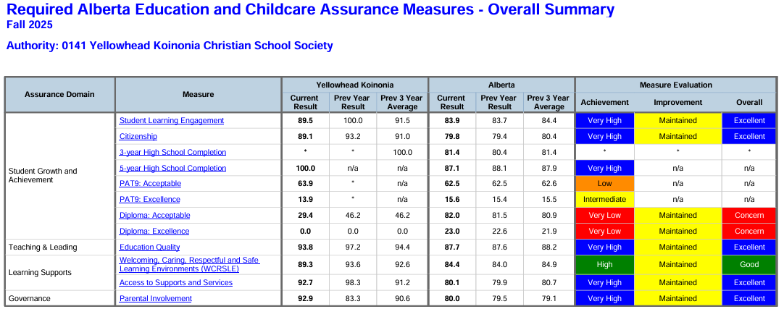

Domain: Student Growth and Achievement

Rationale:
Based on standardized test results, our parent surveys and staff discussion there for systematic emphasis on Math and ELA. Results for Early Years Literacy & Numeracy Assessments can be found in the Appendix.

Education Plan Outcome
Students achieve prescribed provincial learning outcomes, demonstrating strengths in literacy and numeracy.

Comment
Most of our Diploma courses our student results have been suppressed due to small grade size. (See appendix for 2025 graphs). However, because of the grades our students received on Diploma exams, we as a staff are focusing on developing our student standardized test writing skills for our older students this year. PAT Results for FNMI and EAL students can be found in our FNMI and EAL Data Summary Documents also posted to our website.

To make sure that students are meeting Literacy and Numeracy targets we have implemented Literacy Assessments using Acadience (K-6) three times a year as well as the Provincial Numeracy Assessments for K-4. This year we have also started using the computer program, IXL, which assists staff and students in tracking success in Language Arts and Math Curriculum.

**Please see the appendix for further Assurance Report Data

High School Completion Results
The data presented by the government is not entirely a fair representation of YKCS in that a number of students, upon graduation, have gone on to post-secondary institutions that are not recognized for this data (such as Peace River Bible College). Furthermore, we have also added tracking of our students who attend Gap Year Programs (such as Pioneer Ranch Camp’s LEAD) and Mission Organizations (such as YWAM). As such, when this is considered, our transition rate to post-secondary is close to, if not exceeding Alberta averages. Our data, however, does not account for the completion of post-secondary programs.

 | 2014-2015 | 2015-2016 | 2016-2017 | 2017-2018 | 2018-2019 | 2019-2020 | 2020-2021 | 2021-2022 | 2022-2023 | 2023-2024 | 2024-25 | Totals & Percentages
Grade 12 In-Class Students | 4 | 2 | 4 | 1 | 1 | 5 | N/A | 7 | 3 | 4 | 3 | 34
Completed Diploma | 2 | 2 | 4 | 1 | 1 | 4 | N/A | 7 | 3 | 3 | 3 | 30/34  88.2%
Completed Certificate of Completion | N/A | N/A | N/A | N/A | N/A | 1 | N/A | N/A | N/A | 1 | N/A | 2/34  5.9%
Did not Complete High School | 2 | N/A | N/A | N/A | N/A | N/A | N/A | N/A | N/A | N/A | N/A | 2/34  5.9%
Went on to Recognized Post-secondary | 2 | No Data | 1 | 1 | 1 | 1 | N/A | 3 | 0 | 1 | 0 | 10/34  29.4%
Went on to Unrecognized Post-secondary | 0 | 1 | 0 | N/A | N/A | 3 | N/A | 2 | 0 | 0 | 0 | 6/34  17.6%
Gap Year Program  /Missions Organization | No Data | No Data | No Data | No Data | No Data | No Data | No Data | No Data | No Data | 0 | 2 | 2/34  5.9%

Notes:
For the government results, see Appendix 1.
2 In the 2020-2021 school year we did not have any grade 12 students.

Citizenship

Percentage of teachers, parents and students who are satisfied that students model the characteristics of active citizenship.
Achievement |  |  |  | Improvement |  |  | Overall
Very High |  |  |  | Maintained |  |  | Excellent
Overall |  | 2021 |  | 2022 |  | 2023 | 2024 |  |  | 2025
YKCS |  | 97% |  | 87.4% |  | 92.5% | 85.1% |  |  | 89.1%
Province |  | 83.2% |  | 81.4% |  | 80.3% | 79.4% |  |  | 79.8%
Percentage of teachers, parents and students who are satisfied that students model the characteristics of active citizenship.
 | 2021 |  | 2022 |  | 2023 |  |  | 2024 | 2025
YKCS Overall | 97% |  | 87.4% |  | 92.5% |  |  | 85.1% | 89.1%
Parent | 100% |  | * |  | 93.8% |  |  | 93.2% | 92.4%
Student | 90.9% |  | 74.8% |  | 83.5% |  |  | 65% | 74.9%
Teacher | 100% |  | 100% |  | 100% |  |  | 97% | 100%

Student Learning Engagement

The percentage of teachers, parents and students who agree that students are engaged in their learning at school.
Achievement |  | Improvement |  | Overall
Very High |  | Maintained |  | Excellent
Overall | 2021 | 2022 | 2023 | 2024 | 2025
YKCS | 92.9% | 83.3% | 91.1% | 92.5% | 89.5%
Province | 85.6% | 85.1% | 84.4% | 83.7% | 83.9%

The percentage of teachers, parents and students who agree that students are engaged in their learning at school.
 | 2021 | 2022 | 2023 | 2024 | 2025
YKCS Overall | 92.9% | 83.3% | 91.1% | 92.5% | 89.5%
Parent | 100% | * | 97.4% | 100 | 97.4%
Student | 78.6% | 66.6% | 75.9% | 77.5% | 71.1%
Teacher | 100% | 100% | 100% | 100% | 100%

EAL Results

The number of English as an Additional Language (EAL) students at Yellowhead Koinonia Christian School is small enough that Provincial Achievement Test and Diploma Examination results are suppressed by Alberta Education to protect individual privacy.

While standardized performance data are unavailable, teachers closely monitor the progress of EAL learners through classroom assessments, targeted supports, and regular communication with families. The school continues to emphasize language development through differentiated instruction, vocabulary-building strategies, and scaffolding within all subject areas. Our goal is to ensure that each EAL student receives the support necessary to achieve success academically, socially, and linguistically.

EAL Results Summary can be accessed at: https://www.ycschool.ca/APORI_202510_A_0141_Authority_EAL_Report_1.pdf

Domain: Teaching & Leading

Rationale:
To support the school’s strategic priorities, it is essential that we provide opportunities for staff to interact with other professionals, sharing strategies, resources, and gain new perspectives on teaching that will grow their capacity to meet the various needs of students.

Education Quality
Percentage of teachers, parents and students satisfied with the overall quality of basic education.
Achievement |  | Improvement |  | Overall
Very High |  | Maintained |  | Excellent
Overall | 2021 | 2022 | 2023 | 2024 | 2025
YKCS | 96.3% | 92.0% | 94.1% | 91% | 93.8%
Province | 89.6% | 89% | 88.1% | 87.6% | 87.7%

Percentage of teachers, parents and students satisfied with the overall quality of basic education.
 | 2021 | 2022 | 2023 | 2024 | 2025
YKCS Overall | 96.3% | 92.0% | 94.1% | 91% | 93.8%
Parent | 99.2% | * | 93.5% | 97.2% | 91.8%
Student | 89.6% | 84% | 91.5% | 78.2% | 89.6%
Teacher | 100% | 100% | 97.2% | 97.3% | 100%

Professional Learning, Supervision, and Evaluation

Education Plan Outcome
YKCS staff are dedicated to continued growth as educators so that our students can have the greatest success possible.

Comment
For the 2024-2025 staff took part in Professional Development on Classroom Management and created through a template with our staff on improvement goal setting and reflection in this area.
Staff are also welcome to also pursue their own professional development interests and financial support as well as class coverage is available. For the 2025-26 school year, we are planning on developing teacher skills in supporting student Executive Functioning, starting by focusing on one specific student skill.

Teacher growth is supported by our contracted Psychologist, who observes the classroom and then meets with the class team and principal to offer suggestions for implementations and answer any questions staff may have.

Domain: Learning Supports

Rationale:
According to our Christian identity, YKCS should be a place where staff, students and families work together in the context of their real unity in Christ to make the school a community of learning characterized by peace, joy, patience, kindness, self-control, and generosity. Furthermore, when people do not feel safe, they are not effective workers or learners.

Welcoming, Caring, Respectful, and Safe Learning Environment
The percentage of teachers, parents and students who agree that their learning environments are welcoming, caring, respectful and safe.
Achievement |  | Improvement |  | Overall
High |  | Maintained |  | Good
Overall | 2021 | 2022 | 2023 | 2024 | 2025
YKCS | 98% | 90.8% | 93.4% | 86.5% | 89.3%
Province | 87.8% | 86.1% | 84.7% | 93.6% | 84.4%

The percentage of teachers, parents and students who agree that their learning environments are welcoming, caring, respectful and safe.
 | 2021 | 2022 | 2023 | 2024 | 2025
YKCS Overall | 98% | 90.8% | 93.4% | 86.5% | 89.3%
Parent | 100% | * | 94.2% | 93.6% | 94.9%
Student | 94% | 81.7% | 85.9% | 66% | 74.8%
Teacher | N/A | 100% | 100% | 100% | 98.2%

Access to Support & Services
The percentage of teachers, parents and students who agree that students have access to the appropriate supports and services at school.
Achievement |  | Improvement |  | Overall
Very High |  | Maintained |  | Excellent
Overall | 2021 | 2022 | 2023 | 2024 | 2025
YKCS | 96.3% | 86.2% | 89.2% | 90.4% | 92.7%
Province | 82.6% | 86.1% | 80.6% | 79.9% | 80.1%

The percentage of teachers, parents and students who agree that students have access to the appropriate supports and services at school.
 | 2021 | 2022 | 2023 | 2024 | 2025
YKCS Overall | 96.3% | 86.2% | 89.2% | 90.4% | 92.7%
Parent | 100% | * | 90.8% | 98.3% | 93.9%
Student | 89% | 72.4% | 80.1% | 73% | 84.1%
Teacher | 100% | 100% | 96.7% | 100% | 100%

Access to a Continuum of Supports and Services

Education Plan Outcome
Students are active, healthy, and well.

Comment
This outcome was chosen as we found students struggling in multiple areas. Thankfully, over the past year we have seen an increase in our overall and student responses in this area. To support students, we have hired a counselor and an educational psychologist to assist our students, staff, and families. Our psychologist added wraparound work through meetings where admin, staff, and families joined together to create plans that could work at home and school. We continue to offer access to the gym throughout the day for our older students and have a variety of sports teams that students from Grade 5-12 can join.

First Nation Metis and Inuit Student Success
At Yellowhead Koinonia Christian School, the number of self-identified First Nations, Métis, and Inuit (FNMI) students is too small to report Provincial Achievement Test and Diploma Examination results without compromising individual privacy. As a result, Alberta Education suppresses this data.
Although standardized data is unavailable, the school continues to support FNMI students through individualized, relationship-focused approaches. Classroom teachers monitor achievement through ongoing assessment, direct support, and communication with families. We remain committed to fostering a culturally responsive learning environment, integrating Indigenous perspectives where appropriate, and ensuring that each FNMI student is supported in achieving personal success.

The total grant funding received by Y.K.C.S in 2024-25 was $7445.59.

In alignment with the Truth and Reconciliation Commission (TRC) Calls to Action, the school has taken intentional steps to build cultural understanding and awareness. These activities include:
- Orange Shirt Day learning experiences and school-wide reflections on the legacy of residential schools.
- Incorporation of Indigenous histories, cultures, and contemporary issues within relevant classroom units across grade levels.
- Professional development opportunities for staff focused on Indigenous perspectives, reconciliation, and culturally responsive teaching practices.

We remain committed to fostering a respectful, inclusive learning environment that honours Indigenous perspectives while supporting the academic, social, and emotional success of each FNMI student.
FNMI Results Summary can be accessed at: https://www.ycschool.ca/APORI_202510_A_0141_Authority_FNMI_Report_1.pdf

Domain: Governance

Rationale:
It is clear biblically that God-gives fundamental responsibility to parents for the education of their children and yet the whole community of faith that surrounds each child bears responsibility as well. As such, inviting parents especially and community members additionally is essential to fulfilling our mission and meeting the needs of our faith community.

Parental Involvement
Percentage of teachers and parents satisfied with parental involvement in decisions about their child's education.
Achievement |  | Improvement |  | Overall
Very High |  | Maintained |  | Excellent
Overall | 2021 | 2022 | 2023 | 2024 | 2025
YKCS | 93.8% | 96.7% | 91.9% | 85.3% | 92.9%
Province | 89.6% | 89% | 79.1% | 79.5% | 85.7%

Percentage of teachers and parents satisfied with parental involvement in decisions about their child's education.
 | 2021 | 2022 | 2023 | 2024 | 2025
YKCS Overall | 93.8% | 96.7% | 91.9% | 85.3% | 92.9%
Parent | 87.6% | * | 93.8% | 83.3% | 85.7%
Teacher | 100% | 96.7% | 90.0% | 100% | 100%

Budget-Actual Comparison and Audited Financial Statements
The Y.K.C.S budget-actual comparison can be found in the Appendix with the rest of our required audited financial statements. Further information can be acquired by visiting our school office.

Whistleblower Policy:

The policy was adopted March 26, 2014. There were no disclosures reported to the chief officer of Yellowhead Koinonia Christian School during the 2024-25 school year.

Stakeholder Engagement and Accountability and Assurance System:
Yellowhead Koinonia Christian School engages stakeholders in an ongoing review of school results, priorities, and strategies. AERR results are shared and discussed with parents and community members during Society Board Meetings as well as at the annual Society AGM. Staff members review the results during staff meetings and professional development sessions, where they provide input into planning and next steps. In addition, administrators engage in individual conversations with parents and staff to gather feedback and ensure that diverse perspectives inform school decision-making. This collaborative approach supports transparency, shared ownership, and continuous improvement across the school community.

Appendix – Overall Summary

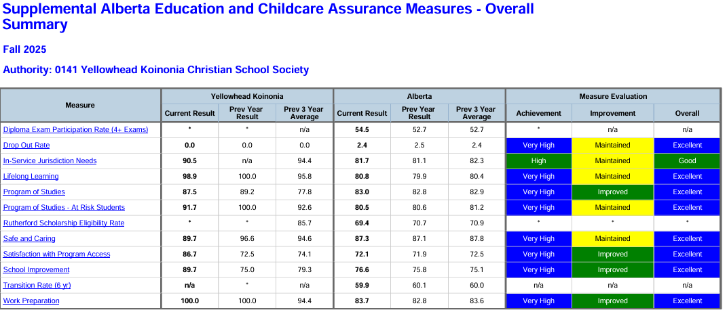

Appendix - Numeracy and Literacy Screenings UPDATE 2025

Numeracy Assessment
 | September 2024 |  |  |  | Jan 2025 |  |  |  |  | June 2025
 | # of Students | NA | RAS | NRAS | # of students | NA | RAS | NRAS |  | # of students | NA | RAS | NRAS
K |  |  |  |  | 7 | 14% | 29% | 57% |  | 2
1 | 12 | 0 | 17% | 83% | 12 | 0 | 18% | 82% |  | 1 |  |  | 100%
2 | 10 |  | 10% | 90% | 9 | 11% | 33% |  | 56% | 4 | 0 | 50% | 50%
3 | 7 | 14% | 86% | 86% | 7 | 0 | 43% |  | 57% | 7 | 0 | 29% | 71%
4 | 13 | 8% | 15% | 77% | 13 | 0 | 31% |  | 69% | 13 | 0 | 33% | 67%
Literacy Assessment
 | September 2024 |  |  |  | Jan 2025 |  |  |  |  | June 2025
 | # of Students | NA | RAS | NRAS | # of students | NA | RAS | NRAS |  | # of students | NA | RAS | NRAS
K | 8 |  |  |  | 9 |  | 5 | 4 |  | 9 | 0 | 4 | 5
1 | 9 |  |  |  | 9 | 1 | 5 | 4 |  | 9 | 0 | 3 | 6
2 | 6 |  | 4 | 2 |  |  |  |  |  | 6 | 0 | 0 | 6
3 | 12 | 1 | 2 | 9 |  |  |  |  |  | 12 | 0 | 0 | 12
4 | 7 | 0 | 0 | 7 |  |  |  |  |  | 7 | 0 | 0 | 4

For Grades 1-6 we benchmark our students three times of year (September, January, and June) while Kindergarten happens in January and June. As we see literacy as an area of growth, we also run an intervention program 4 days a week for these students (25 mins/day). The students are grouped in areas of need based on the data. We also progress monitor biweekly or monthly depending on the needs of the child.

Appendix - YKCS Audited Financial Statements

Please click on the link to view our 2024-2025 audited financial statements.

Appendix - AERR Original Data
